**Experiment 3 - Raman**

Peppers were inoculated from 03.03.25 to 12.03.25 at 22°C.

Seeds were checked on 12.03.25.

Each measurement is an average of 10 measures.

Experimental Groups:

1. Control – 1 mL of autoclaved H20 injected through the blossom end.
2. Placenta infection – 100 µL of *Alternaria alternata* suspension (C = 10⁸ spores/mL) injected through the blossom end.
3. Full infection – 1 mL of *Alternaria alternata* suspension (C = 10⁸ spores/mL) injected through the blossom end.

Infection Levels:

1. Level 1 – No infection; no infection can be spotted even under a binocular microscope (seeds from the Group 1).
2. Level 2 – Very mild infection; infection can barely be seen without a binocular microscope (seeds from Group 2).
3. Level 3 – Mild infection; infection is visible but not obvious (seeds from Group 2).
4. Level 4 – Severe infection; infection is clearly visible (seeds from Group 3).

**Opened Pepper**

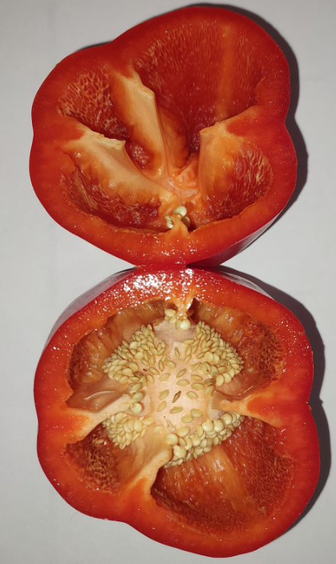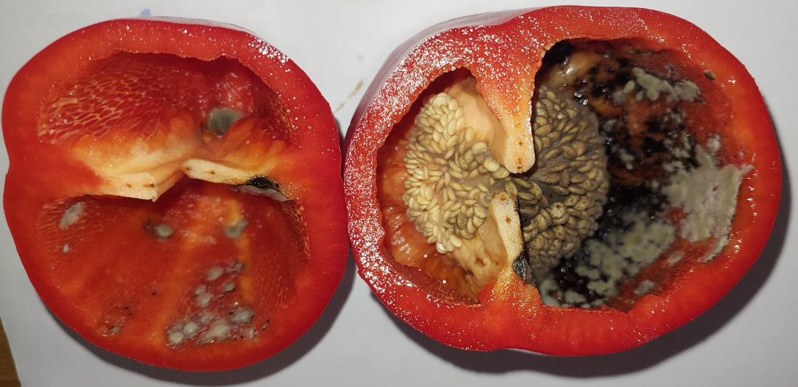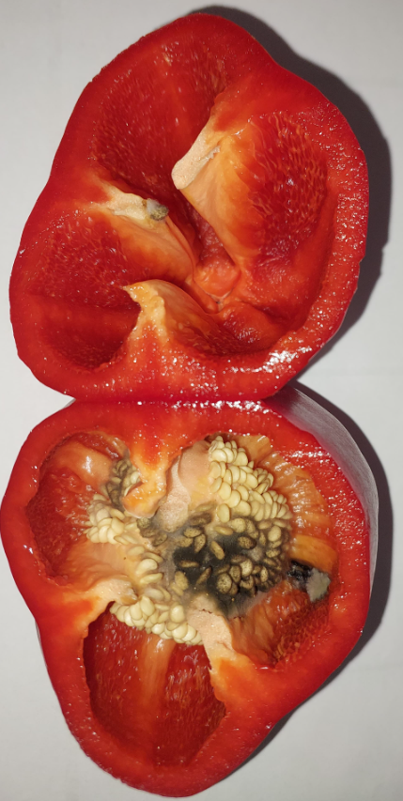

**Group 2**

**Group 1**

**Group 3**

**Placenta**

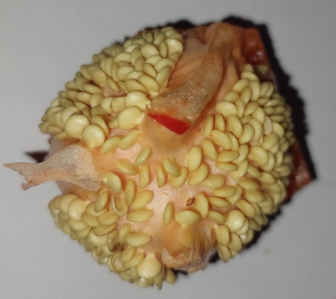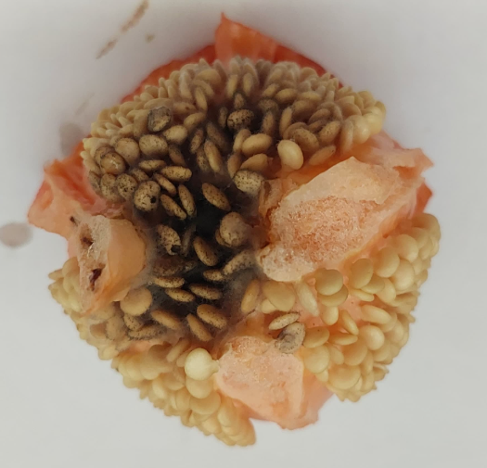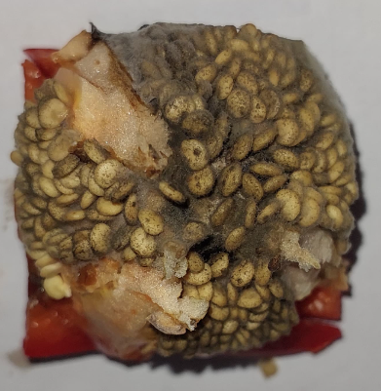

**Group 1**

**Group 2**

**Group 3**

**Seeds**

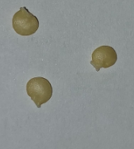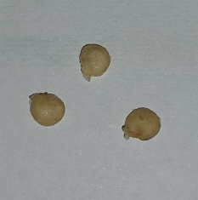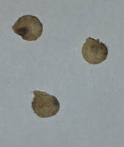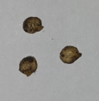

**Level 1**

**Level 2**

**Level 4**

**Level 3**

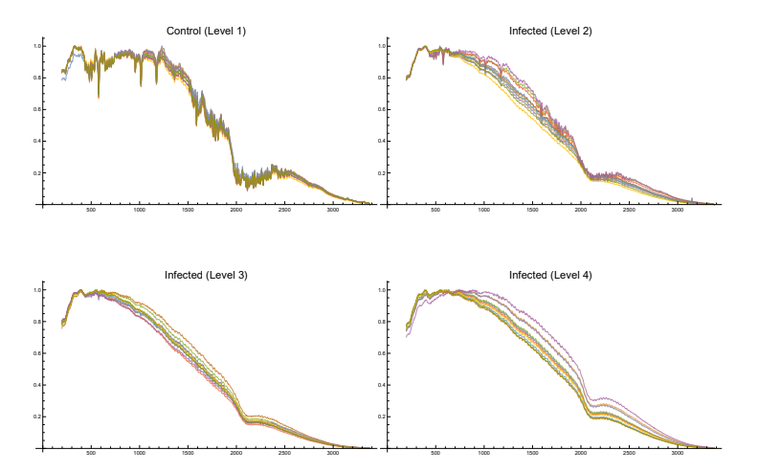**Graphs**